Friday 9th 2012
North and Central Surabaya
No | Time | Destination | Explanation
 |  | Tugu Pahlawan  Jalan Pahlawan | The Heroes Monument is a warrior spirit symbol of “"arek-arek Suroboyo"” (Surabaya's People) in faced the colonist. The warrior monument is located in Tembaan Street. It had built for the agenda of giving high respect to all warriors that had killed during big encounter to fight against ally army being hitchhiked by NICA, which wish to occupy Surabaya in 10 Novembers 1945. It is located in front of luxury Gubenur office. | 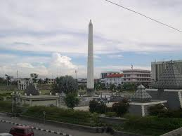
 |  | Kepanjen Church  Jalan kepanjen 4-6 Surabaya | The Church that being built in 1899 is the eldest church in Surabaya, but has just been applied one year then post it development. This postponement is caused by the church function, which have time to be displaced functioned as field hospital to overcome cholera epidemic. | 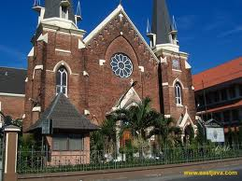
 |  | Kebon Rojo Post Office  Jalan kebonrojo 10 | In 1881 was used as residence of Bupati Karesidenan Surabaya. In 1925 was used as HBS Hogere Burger School (high school) then used as Police headquarters. In 1926-1928 was renovated by GJPM Bolsius and used as post office up to now | 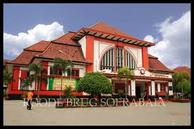
 |  | Polwiltabes Surabaya  Jalan Taman Sikatan 1 Surabaya | It was built in 1850 and used as Police station since Dutch an Japan colonization. | 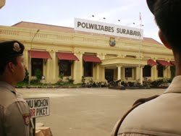
 |  | Gedung Bank Mandiri  Persimpangan jalan Pahlawan dan Jl kebon Rojo | Formerly names Lindeteves Stokvis Building, this building was build in 1911 by Hulswit. During Dutch colonization, was used as machine factory, and during Japan colonization was used as repair shop and storage of vehicles and weapons | 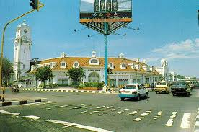
 |  | Gedung kantor Gubernur  Jalan Pahlawan 110 | It was built by Nedrlandsche Aanneming-Maatschappij with the architect W Lemei , H. A Breunig and W.B Carmiggelt . On December 10th 1931 was opened as Governor office. | 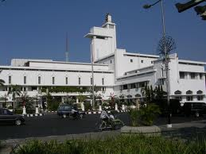
 |  | Ex Bank Indonesia  Jl Garuda | It was built in 1912 by Hulswit and Cuyper  De Javasche Bank is a leading commercial bank that was established in Batavia on January 24, 1828. Surabaya branch office was opened on 14 September 1829 and was first implemented accounting system clearing among the six major banks. This building was formerly functioning as an operational office of Bank Indonesia Surabaya. | 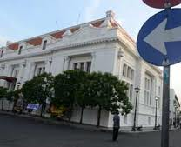
 |  | Gedung Pelni  Jalan Pahlawan 114 | KPM (Koninklijke Maatschappij Paketvaart),buildings are buildings owned shipping company during Dutch colonization.  It was built in 1920s | 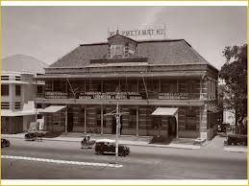
 |  | Gedung Soeara Asia  Jalan Pahlawan 116 | It was built in 1912. In 1930s , Pottrel, published Soerabaiasch Handelsblad, the oldest newspaper in Surabaya. This building was also used as Domai news office, where Indonesian Proclamation 1945 was distributed on 18th August 1945. | 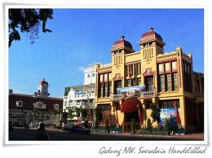
 |  | Gedung PLN Gemblongan  Jalan Gemblongan | It is the former office of ANEIM (General Electric Company Dutch East Indies)  It was built in 1908s | 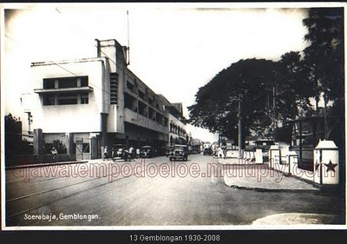
 |  | Tugu Pahlawan  Jalan Pahlawan | The Heroes Monument is a warrior spirit symbol of “"arek-arek Suroboyo"” (Surabaya's People) in faced the colonist. The warrior monument is located in Tembaan Street. It had built for the agenda of giving high respect to all warriors that had killed during big encounter to fight against ally army being hitchhiked by NICA, which wish to occupy Surabaya in 10 Novembers 1945. It is located in front of luxury Gubenur office.
 |  | PLN Gemblongan  Jalan gemblongan 64 | It was built in 1908s as ANIEM (Algemeene Nederlandsch-Indische Eletriciteits Maatschappij = Perusahaan Listrik Umum Hindia Belanda) | 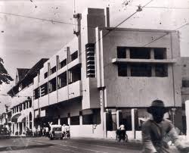
 |  | Gedung Cak Durasim  Jl gentengkali 58 | Cak Durasim building is known as the general public arts and cultural center and arts such as theater, dance, music, puppetry, art exhibitions and so on.  Cak Durasim building islocated in East Java Cultural Park (TBJT: taman Budaya Jawa Timur), which according to history that the complex was once the home of Kanoman regent and district administrative center "Soerabaia" in the Dutch colonial period, supposedly built in 1915. | 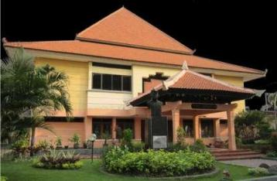
 |  | Gedung Tunjungan City (SIOLA) | Siola building was first constructed in 1877 and occupied the store Whiteaway Laidlaw & Co. owned British businessman Robert Laidlaw (1856-1935), who sells textiles and clothing, and then had grown to be the largest department store in the East Indies. | 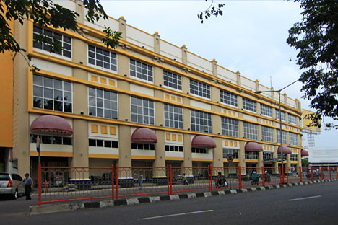
 |  | Hotel Majapahit  Jalan Tunjungan 65 Surabaya | Hotel Majapahit was founded in 1910 as Hotel Oranje by Lucas Martin Sarkies. It was named after the historic kingdom of Majapahit. It was formerly operated by the Mandarin Oriental group.  During the Japanese occupation of Indonesia the hotel name was changed to Yamato Hotel. The hotel was the site of the famous "Insiden Hotel Yamato" (in English "Hotel Yamato incident") in which young Indonesian revolutionaries tore the blue part of the Dutch flag flown in the hotel to change it to the Indonesian flag in the lead up to the Battle of Surabaya. | 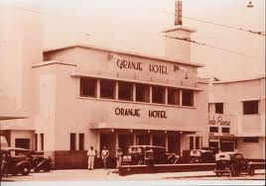
 |  | Halo Surabaya Restaurant  Jalan Bubutan no 95 Surabaya |  | 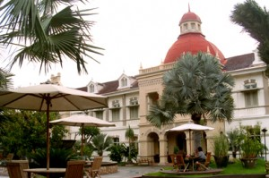
 |  | PTPN Building  Jalan Merak no 1 | HVA (Handelsvereeniging Amsterdam) building now become PT. Plantation Nusantara XI (Persero) building, which located in Merak Street 1; Surabaya had built on 1920 and finished on 1925. Its designer is famous architect bureau from Batavia, Hulswit, Fermont & Ed. Cuypers. HVA building is the biggest building in Surabaya (finished about 3000 M3 concrete). Its architect tries to bring the local traditional elements as it decorative manner, to give the local identity characteristic.  The history of the company started with nationalization of foreign plantation companies owned by Dutch colonial by the government of Indonesia in 1958 to become State Plantation Company
 |  | SMA Saint Louis | Built in 1923, the architect Hulswit, Fermont & Ed. Cuypers of Weetenreden Batavia. Formerly used as a headquarters Syuu Tokubetsu Keisatsutai Surabaya or Surabaya Residency Special Police Forces.  In 1943 is used for Special Police Headquarters led M.Yasin. On August 20, 1946 in the building that replaced benderaHinomaru decline with the flag and continued takeover of weapons by members of the Special Police of the Japanese. In 1949, the building was used for the Mobile Brigade headquarters, then on August 1, 1951 began to be used for a Catholic high school St. Louis I, headed by Brother Aloysius.ins | 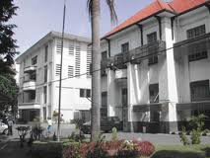
 |  | Gereja HKY  Jalan Polisi Istimewa 15 Surabaya | It was build at 27 April 1914. The designer was Ed Cypres Bureau and the architect was Huswit-Fermont. It was used firstly on 21st July 1921. | 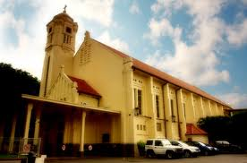
 |  | Rumah Sakit Darmo | The hospital building at Jalan Darmo Darmo was founded in 1919. The architect was G.C. Citroen, a renowned architect in Surabaya. Citroen is the designer of the building: Surabaya municipality, home office Surabaya mayor Jimerto roads, bridges Gubeng, palace garden wooden bridge (now replaced), Wonokromo bridge, Viaduct Street Hero, etc. Malang city hall interior. His name was listed as a famous architect from Surabaya. | 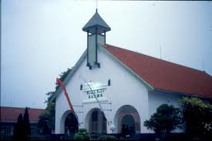
 |  | Gedung Wismilak  Jl. Dr. Soetomo 27 Surabayaa | It was build around 1920s | 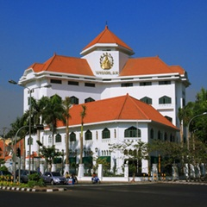
 |  | SMA Santa Maria  Jalan Raya Darmo | Santa Maria High School is one of cultural heritage in Surabaya. The school is located on Jalan Raya Darmo (formerly named Jalan Kupang) was founded by the Order of Santa Ursula on June 26, 1922 | 