Thursday 8th 2012
South and East Surabaya
NO | Time | Destination | Explanation
 | 7:45 | Tanjung Perak | Traditional Harbour  Port of Tanjung Perak is one of gateways of Indonesia, which becomes goods collector and distribution from and to Eastern Indonesia including East Java.  It was build around 1910s by two experts from the Netherlands namely, Prof DR. Kraus and G.J. de jong. | 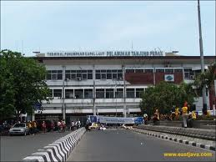
 | 8:45- | Jembatan Petekan | NV Braat and Co. makes the bridge, which in Dutch language called “"Ophaalbrug"”, around of 1900. The bridge is design able to boost up and degraded because at that moment Kalimas River become the main transportation line of traditional boat, which bring goods to the commerce area in Kembang Jepun. | 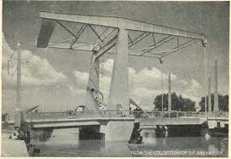
 | 09:00 | Gedung Internatio  Jalan Jayengrono  Sudut jalan Rajawali dan Jalan Jayengrono  Sekarang Kantor PT Tjipta Niaga | Internatio Building (Internationale Crediten Handelvereeniging) is located in angle of Heerenstraat and Willemsplein (now called Jayengrono Street). This building had built in 1929 by Biro Aristech AIA (Algemeen Ingenieurs en Architecten Bureau) that address in Sumatrastraat 59 Soerabaia. | 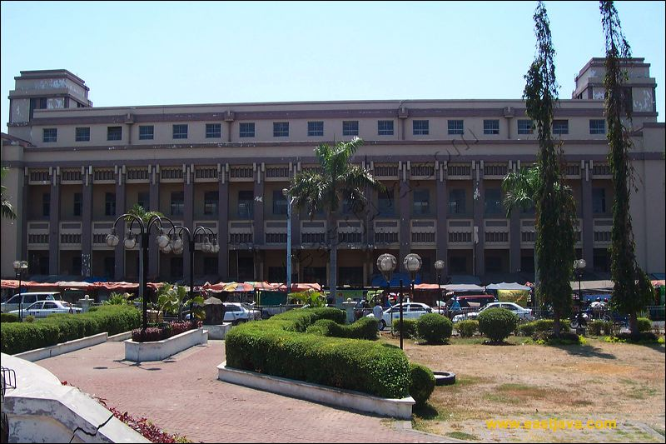
 |  | Jembatan Merah | Translated as The Red Bridge which located at North Surabaya, in whose surrounding is one the most savage fightings ever seen on Java. The battle of Surabaya began on 10th November 1945, less than three months after the proclamation of the Indonesian independence day which readed in Jakarta and it was right here that Brigadir General Mallaby from England was killed.Jembatan Merah (Red Bridge) Area was a trade area that grows as the consequence of Paku Buwono II Agreement from Mataram with VOC by 11 Novembers 1743. In that agreement some of north coast areas, include Surabaya, delivered his domination to VOC. After that, Surabaya resided fully in Dutch power. | 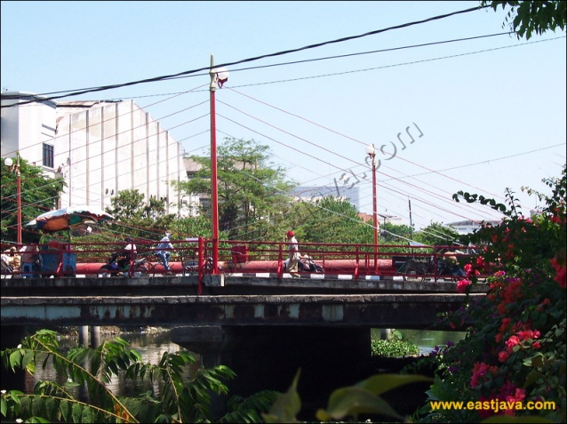
 | 09:30 | Kembang Jepun | Kembang Jepun is the eldest area in Surabaya city, because it resides in Kalimas stream and close to Tanjung Perak port. In its ancient building line even most its paint is sleazy and dusty and matt enunciated because as the commerce center.  In west of Jembatan Merah (Willenstraat) like Rajawali Street (Heerenstraat) had fulfilled some merchants from Europe. The Chinese Public (Tionghoa) stayed there since 1411 occupying a "Chinese Kampong" region eastside of Kalimas. Karet Street (Chinesevorstraat), Kembang Jepun Street (Hendelstraat) is the Chinese residence | 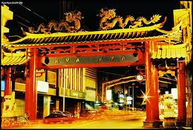
 |  | Klenteng Hok Ang Kiong  Jl Coklat No. 2 Surabaya, Jawa Timur. | Reputedly the oldest temples in Surabaya was founded in year 1830 by Hok Kian Kong Tik, gathering the Chinese origin of Hok Kian | 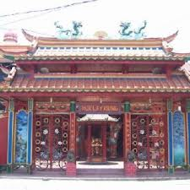
 |  | Kapasan (Klenteng Bon Bio)  Jalan Kapasan 131 Surabaya | Boen Bio Pagoda is the last bastion of defense Khong Hu Chu religion in Surabaya. This pagoda was originally named Boen Thjiang Soe, founded in 1883, is located on the road Kapasan 131, Surabaya.  Initially, the temple was completed in 1883 at Kapasan In. In 1907, he moved to Jl. Kapasan to make it easily access. | 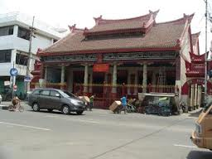
 | 11:15 | Tugu Pahlawan+  Jalan Pahlawan Surabaya  Turun Bus | The Heroes Monument is a warrior spirit symbol of “"arek-arek Suroboyo"” (Surabaya's People) in faced the colonist. The warrior monument is located in Tembaan Street. It had built for the agenda of giving high respect to all warriors that had killed during big encounter to fight against ally army being hitchhiked by NICA, which wish to occupy Surabaya in 10 Novembers 1945. It is located in front of luxury Gubenur office. | 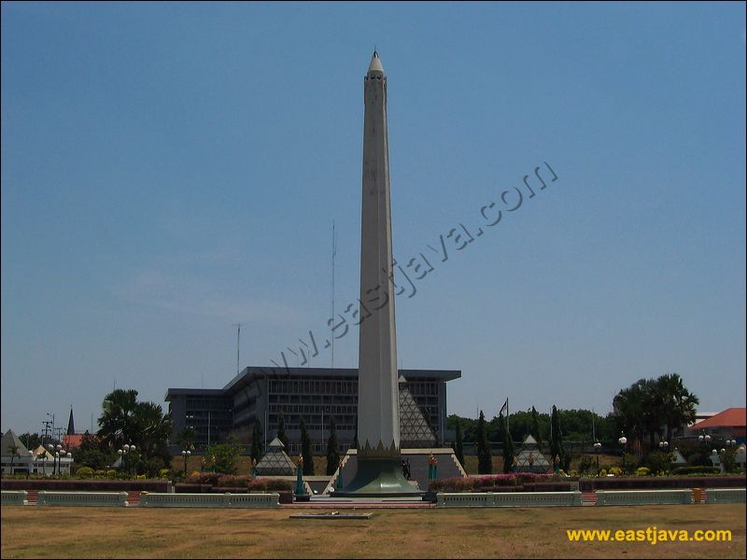
 |  | Halo Surabaya  Jalan Bubutan no 95 Surabaya |  | 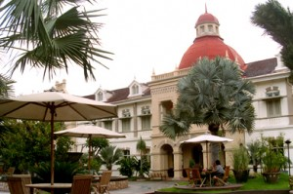
 | 13:15 | Cheng Hoo  Jalan Gading Surabaya | Cheng Hoo Mosque inspired from Niu Jei Mosque in Beijing, China, being built in 996 A.D. But, the development of new Cheng Hoo mosque executed by 10 March 2002 and opened in 13 Octobers year past.  It is built by allying Islam culture, Java, and Chinese that predominated by green color, turned yellow, and squeezed. The form of the building is typical of Chinese with 'Joglo' Java. This is show tightly between Chinese cultures and Java, which have intertwined since former. Cheng Hoo is also inspiration name of 'Admiral Cheng Hoo', which become a Moslem when admission to Majapahit empire. | 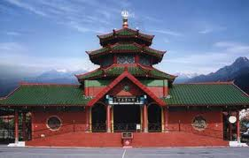
 |  | SMA Saint Louis | Built in 1923, the architect Hulswit, Fermont & Ed. Cuypers of Weetenreden Batavia. Formerly used as a headquarters Syuu Tokubetsu Keisatsutai Surabaya or Surabaya Residency Special Police Forces.  In 1943 is used for Special Police Headquarters led M.Yasin. On August 20, 1946 in the building that replaced benderaHinomaru decline with the flag and continued takeover of weapons by members of the Special Police of the Japanese. In 1949, the building was used for the Mobile Brigade headquarters, then on August 1, 1951 began to be used for a Catholic high school St. Louis I, headed by Brother Aloysius.ins | 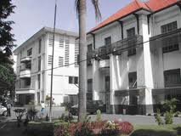
 |  | Gereja HKY  Jalan Polisi Istimewa 15 Surabaya | It was build at 27 April 1914. The designer was Ed Cypres Bureau and the architect was Huswit-Fermont. It was used firstly on 21st July 1921. | 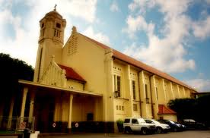
 |  | Rumah Sakit Darmo | The hospital building at Jalan Darmo Darmo was founded in 1919. The architect was G.C. Citroen, a renowned architect in Surabaya. Citroen is the designer of the building: Surabaya municipality, home office Surabaya mayor Jimerto roads, bridges Gubeng, palace garden wooden bridge (now replaced), Wonokromo bridge, Viaduct Street Hero, etc. Malang city hall interior. His name was listed as a famous architect from Surabaya. | 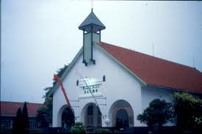
 |  | Gedung Wismilak  Jl. Dr. Soetomo 27 Surabayaa | It was build around 1920s | 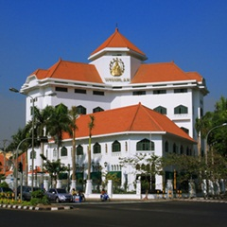
 |  | SMA Santa Maria  Jalan Raya Darmo | Santa Maria High School is one of cultural heritage in Surabaya. The school is located on Jalan Raya Darmo (formerly named Jalan Kupang) was founded by the Order of Santa Ursula on June 26, 1922 | 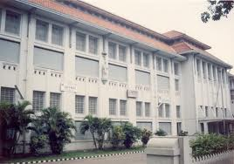

7:45 Sekolah Ciputra
08:45 - 09:00 Pelabuhan Perak -Petekan
09:00 – 09:30 JMP
09:30 – 10:30 Jalan Sikatan, Jln karet, Kya-Kya, Kapasan, Pasar Atom
11:15 – 11: 30 Tugu pahlawan - Halo Surabaya
11:30 – 12:15 Halo Surabaya
12:15 – 12 :45 Halo Surabaya – Jln Pahlawan – Gemblongan – Ngemplak _- Cheng Ho
13:15 – 14 : 30 Cheng Ho – Pemuda – Panglima Sudirman – Raya Darmo

